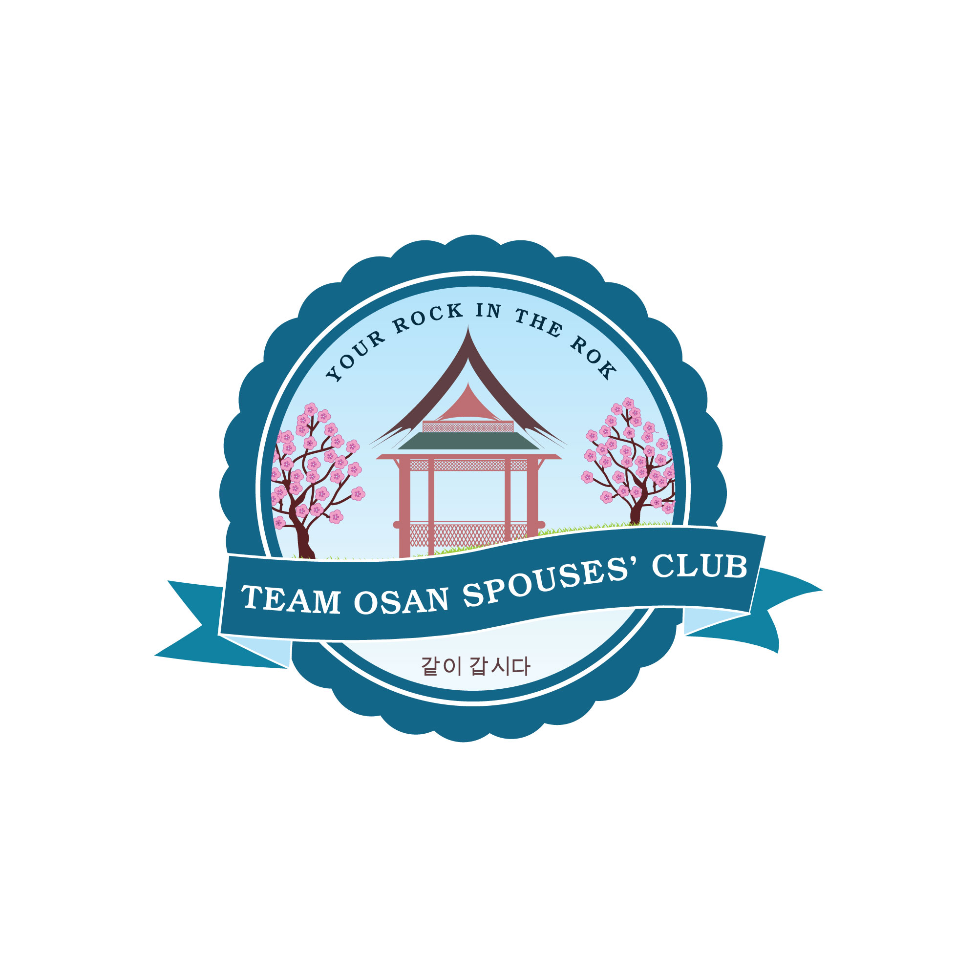

TEAM OSAN SPOUSES’ CLUB GENERAL BOARD
MEMBER APPLICATION
2019-2020 YEAR

Name:

Cell #: Email:

Date of application:

Please check if you have read the Job Description for which you would like to apply. ______

Have you ever served in a board position in a Spouses Club? ___Yes ___No

If yes, please list the position(s) you held, dates, the club name and location where you served.
_______________________________________________________________________________________________________________________________________________________________________________________________________________________________________________________________________________________

Please describe your past positions or jobs (volunteer or paid) that you feel qualify you for this position. (You may use a separate sheet of paper)
__________________________________________________________________________________________________________________________________________________________________________________________
_____________________________________________________________________________________________

____________________________________________________________
Signature
Please annotate your first, second and third choice

Appointed Offices:

___Membership ___Publicity ___Wild West Night Chair
___Thrift Shop Chair ___Historian ___Reservations
___Scholarship ___Ways & Means ___Member-At-Large
___Community Grants ___Web Master
___Special Activities ___Programs
___Operation Sweet Treat ___Parliamentarian

